

Colegio Tecnológico Pulmahue

TERCERO MEDIO
Name:
El objetivo de esta guía es que los estudiantes recuerden vocabulario sobre profesiones y trabajos uniendo la definición con la palabra correcta e imagen. Luego escriban sobre que trabajos o profesiones quieren tener en un futuro.
Para dudas que tengan pueden escribirme un correo a esta dirección: yorka.sepulveda.pulmahue@gmail.com, escribiendo en el asunto el nombre de él o la estudiante y su curso, el horario para correos es de 9am a 7pm. Cualquier consulta sobre los contenidos y asignatura será respondida y también en caso de que necesiten material extra.
O.A: Recordar vocabulario de trabajos y profesiones.
O.A2: Escribir sobre trabajos y profesiones que deseen seguir.

What job is it?
Match the job to the correct description

Job Description

- Police Officer T a) person who drives a bus
- Cook b) person who teaches students
- Waiter c) person who makes and designs clothes
- Fashion designer d) works in a hospital and helps doctors
- Movie director e) person that can draw cartoons well
- Pilot f) rescues people from burning buildings and helps put out fires
- Writer g) person who drives a taxi
- Cartoonist h) someone who can sing well
- Basketball player i) works in a hospital and cures sick people
10. Bus driver j) flies an airplane
11. Scientist k) person who acts in a movie
12. Teacher l) does the cooking in a restaurant
13. Journalist m) takes people’s orders in a restaurant and serves food
14. Doctor n) person who reports news on TV, radio or newspaper
15. Nurse o) someone who writes books and stories
16. Farmer p) works in a laboratory and does experiments
17. Actor q) someone who makes movies
18. Firefighter r) person that can play basketball well
19. Singer s) works on a farm and grows crops or looks after animals
20. Taxi driver t) works in a police station and keeps people safe
21. Mechanic u) plays the piano well
22. Engineer v) person in the army who wears a uniform and has a gun
23. Pianist w) works in an animal hospital and looks after sick animals
24. Soldier x) repairs machines and vehicles such as cars and buses
25. Hairdresser y) someone who designs and constructs buildings
26. Veterinarian z) someone who cuts and styles hair


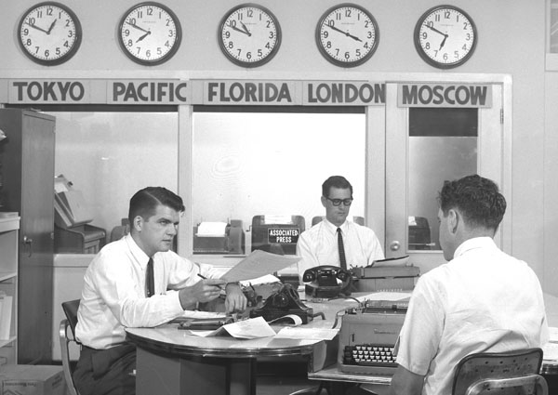
WHAT DO THEY DO?
♣ WRITE THESE SENTENCES UNDER THE CORRESPONDING PICTURE:

-They work in a hospital. - She meets people from different countries.
- They wear an uniform. - She speaks three languages.
- She helps people. - They work on a computer
- She sells things. - She works in a shop.
- They help sick people. - She translates things.
- She works at the United Nations. - They ask people questions.
- They work in a newspaper office. - They work with doctors.
- She looks after money. - They write a lot.


They work in a hospital.

Learning about a Job
Instructions: If you want to get a particular type of job, you need to design your resume to highlight the skills and experience you possess to fit that job. That means you'll probably have to conduct a bit of research to see what potential employers are looking for.

Answer the questions below based on the type of job you hope to obtain.

1. What are some of the job titles you plan to apply for?

2. What type of degree or training is required for the job?

3. What courses that you've taken are relevant to the job?

4. What are the duties of a person in that position?

5. What skills should a person in that position possess?

6. What experience is needed to get the job?

